Rider Resume Questionnaire

Full Name:
Address:
Email Address:
Phone:
*If you choose not to list all these details, that is fine, it’s completely up to you
Short Bio: (just a brief description of who they are and what sets them apart from the majority of their competitors.)

Date of Birth: _{(and age as determined by AMA)}
Bike(s):
Classes:
Any and all media exposure: (Newspaper clippings, Online ads, etc.)

Current Sponsors:

2020 Highlights: Best race/series results and class in which they achieved these results, and/or you can include all race results.

Goals for the 2021 Season:

Additional achievements: both in and outside of motocross: school related, community, etc.
Pictures: Required [Headshot & 1 Action-Shot]. Include others if possible.)

- If you have any social media links related directly to the rider, please be sure to include that information as well. The more pictures I have to work with, the better.

- Feel free to submit answers on a separate page or add to this document.

Thank you,

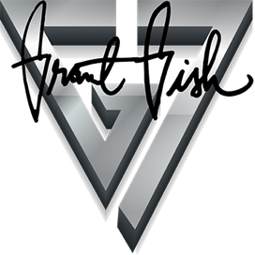
Grant Gish
G7, LLC
grant@g7llc.net
(405) 517 - 0377

